Algebra 1: Unit 7, Lesson 4

- Taylor is factoring $3x^{2}+7x+2$ by grouping. His partial work is shown in the table. Complete the missing step.
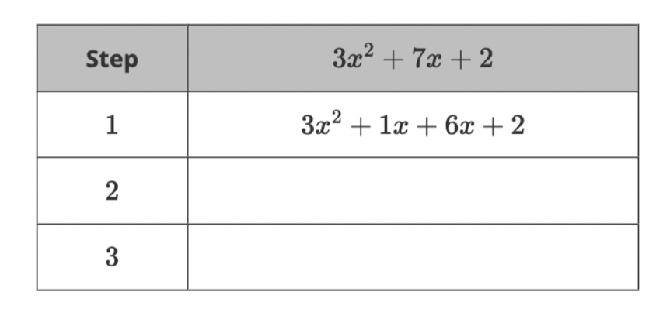
$$(x+2)(3x+1)$$

$$x\left(3x+1\right)+2(3x+1)$$

- What is the factored form of the trinomial $h^{2}-h-42$?

$$(h-7)(h+6)$$

- Brody is factoring $3x^{2}+11x-20$by grouping.
Write the equivalent expression in the factored form.

$$(x+5)(3x-4)$$

